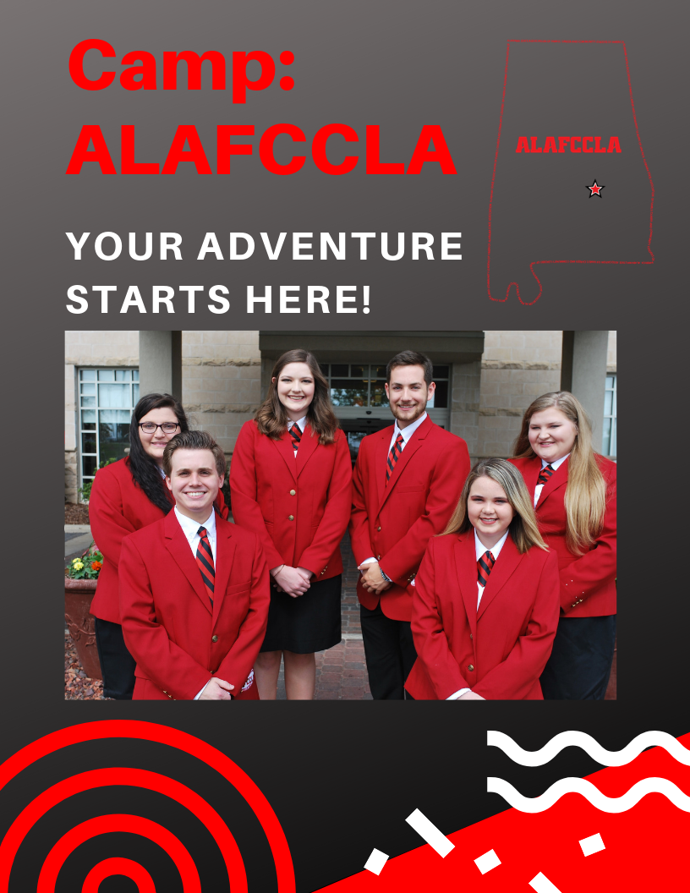

Alabama FCCLA State Leadership Conference
March 14-15, 2019 | Montgomery

2018-2019 Alabama FCCLA State Officer Team

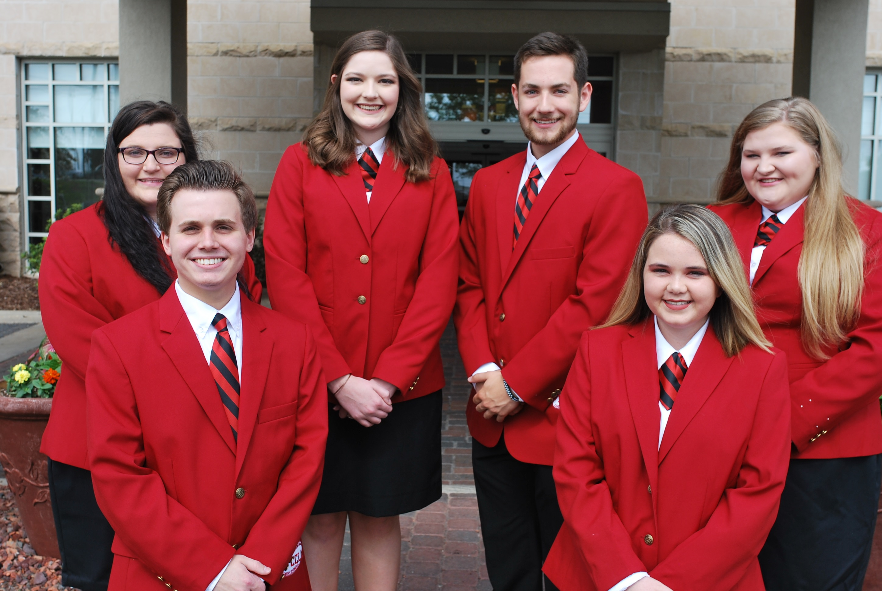

Anna Frances Taffar
President

Tyler Brown
First Vice-President

Tiffani Tyson
Vice-President of Programs

Carson Silas
Vice-President of Membership

Caitlyn Himburg
Vice-President of Community Service

Kamryn Miller
Vice-President of Star Events

Connect Online! Go to http://alabamafccla.org/state-officers and:
- Download State Officer Candidate Resources
- Request a Chapter Visit
- Email your state officers

Check the Alabama FCCLA website for more information http://alabamafccla.org/documents

EVENT ESSENTIALS
Alabama Association of Family, Career and Community Leaders of America and the Alabama State Department of Education are excited to invite your ALAFCCLA local chapter to the Alabama Association of FCCLA State Leadership Conference, March 14-15, 2019, where ALAFCCLA members will be a part of “Camp: ALAFCCLA”. Registration opens January 1, 2019.

The Renaissance Montgomery Hotel & Spa at the Convention Center and the Montgomery Performing Arts Centre will be the site of ALAFCCLA’s State Leadership Conference (SLC). During the conference, Alabama’s finest high school members will have the opportunity to:
- Test leadership and career skills in competitive events
- Compete for the opportunity to advance to the FCCLA National Leadership Conference
- Earn recognition and attend stimulating leadership sessions
- Run for election to an ALAFCCLA state office and elect state leaders
- Participate in fun entertainment and activities
- Meet and network with fellow members, advisers, and industry and community leaders
- Enjoy fun and engaging general sessions
- Earn honors and scholarships as one of the best Career and Technical Student Organizations in education

Event Essentials
Registration Opens Tuesday, January 1, 2019
SLC Dates Thursday – Friday, March 14-15, 2019
Venue Renaissance Montgomery Hotel & Spa at the Convention Center
Montgomery Performing Arts Centre
Location 201 Tallapoosa St, Montgomery, Alabama 36104
Registration Fee $40 for all students, advisers, chaperones, and guests
(Complimentary for current state officers)
Guests and chaperones wishing to attend Opening Session only cost will be $15.00
Guests and chaperones wishing to attend Closing Session only cost will be $15.00
Registration Deadline Friday, February 1, 2019 (5:00 p.m. central)
Hotel Room Rate $136.00 per room per night (plus taxes), $157.29 inclusive
Hotel room rates are subject to applicable state and local taxes (currently 14% + $2.25) in effect at the time of check-out.
Hotel Cut-Off Date Wednesday, February 8, 2019
Late Registration Not Accepted
Registration Payment Must postmarked by February 15. 2019 or a late payment fee of $25.00 will be added to the overall chapter bill.
SLC Information www.alabamafccla.org/documents
Registration Link https://www.registermychapter.com/fccla/al
Hotel Registration (334) 481-5000
Bus Parking Will be announced closer to event
Name Badges Required for entry to all events

Alabama FCCLA Business Office
Send registration payments to:
Alabama FCCLA Business Office
P.O. Box 1440
Owasso, OK 74055
Email: finance@alabamfccla.org
Phone: (334) 450-2723

Online Access to Materials
Check out the Alabama FCCLA website for the latest information and updates. Point your browser to www.alabamafccla.org/documents and scroll to State Leadership Conference.

Renaissance Montgomery Hotel & Spa at the Convention Center
Alabama FCCLA is privileged to celebrate the capstone of the FCCLA experience in Alabama at the amazing Renaissance Montgomery Hotel & Spa at the Convention Center! In addition to the incredible opportunities in competition and leadership development, FCCLA members will enjoy one of Montgomery’s top hotels.

A leader in modern luxury, Renaissance Montgomery Hotel & Spa at the Convention Center provides upscale comfort in the center of Alabama's state capital. Its rooms offer stylish escapes with floor-to-ceiling windows, room service and plush bedding to make you feel refreshed and well-rested before a memorable day. Complimentary Wi-Fi and premium movie channels is provided in all rooms.

Nearby Dining Options
Many excellent restaurants and dining options are within walking distance of the hotel, including:

- House (in the Renaissance)
- Wintzell’s Oyster House
- Sa Za (Italian)
- Dreamland BBQ
- Cucos Mexican Café
- Express
- Central at 129 Coosa
- Mellow Mushroom
- Lek’s Thai
- Burger King
- Jimmy Johns
- Mama Goldburg More!

PROGRAM PREVIEW

This year’s SLC includes more leadership programming than ever before! Whether your members are competing, attending for the leadership and career development programming, or networking with other members, there will be activities and sessions planned throughout both days to keep your students engaged, active, and connected.

Theme
This year’s theme is Camp: ALAFCCLA “Your Adventure Starts Here!”.

Tentative Agenda
Agenda is tentative and subject to change, without notice.

THURSDAY, MARCH 14
8:00 AM Check-In
9:00 AM – 5:00 PM Camp: ALAFCCLA STAR Events
11:00 AM – 1:00 PM Lunch (on your own)
1:00 PM Camp: ALAFCCLA Your Adventure Starts Here! Exhibitor Showcase
Afternoon Camp: ALAFCCLA S’more Fun Showcase
Afternoon Camp: ALAFCCLA Your Adventure Starts Here! Leadership & Career Development Workshops
Evening Dinner (on your own)
7:00 PM Camp: ALAFCCLA Opening Session
11:00 PM Curfew

FRIDAY, MARCH 15
Morning Breakfast (on your own)
8:00 AM – NOON Camp: ALAFCCLA STAR Events
Morning Camp: ALAFCCLA Your Adventure Starts Here! Leadership & Career Development Workshops
11:00 AM – 12:30 PM Lunch (on your own)
1:30 PM Camp: ALAFCCLA STAR Events Awards Ceremony and Closing Session
Camp: ALAFCCLA Showcase
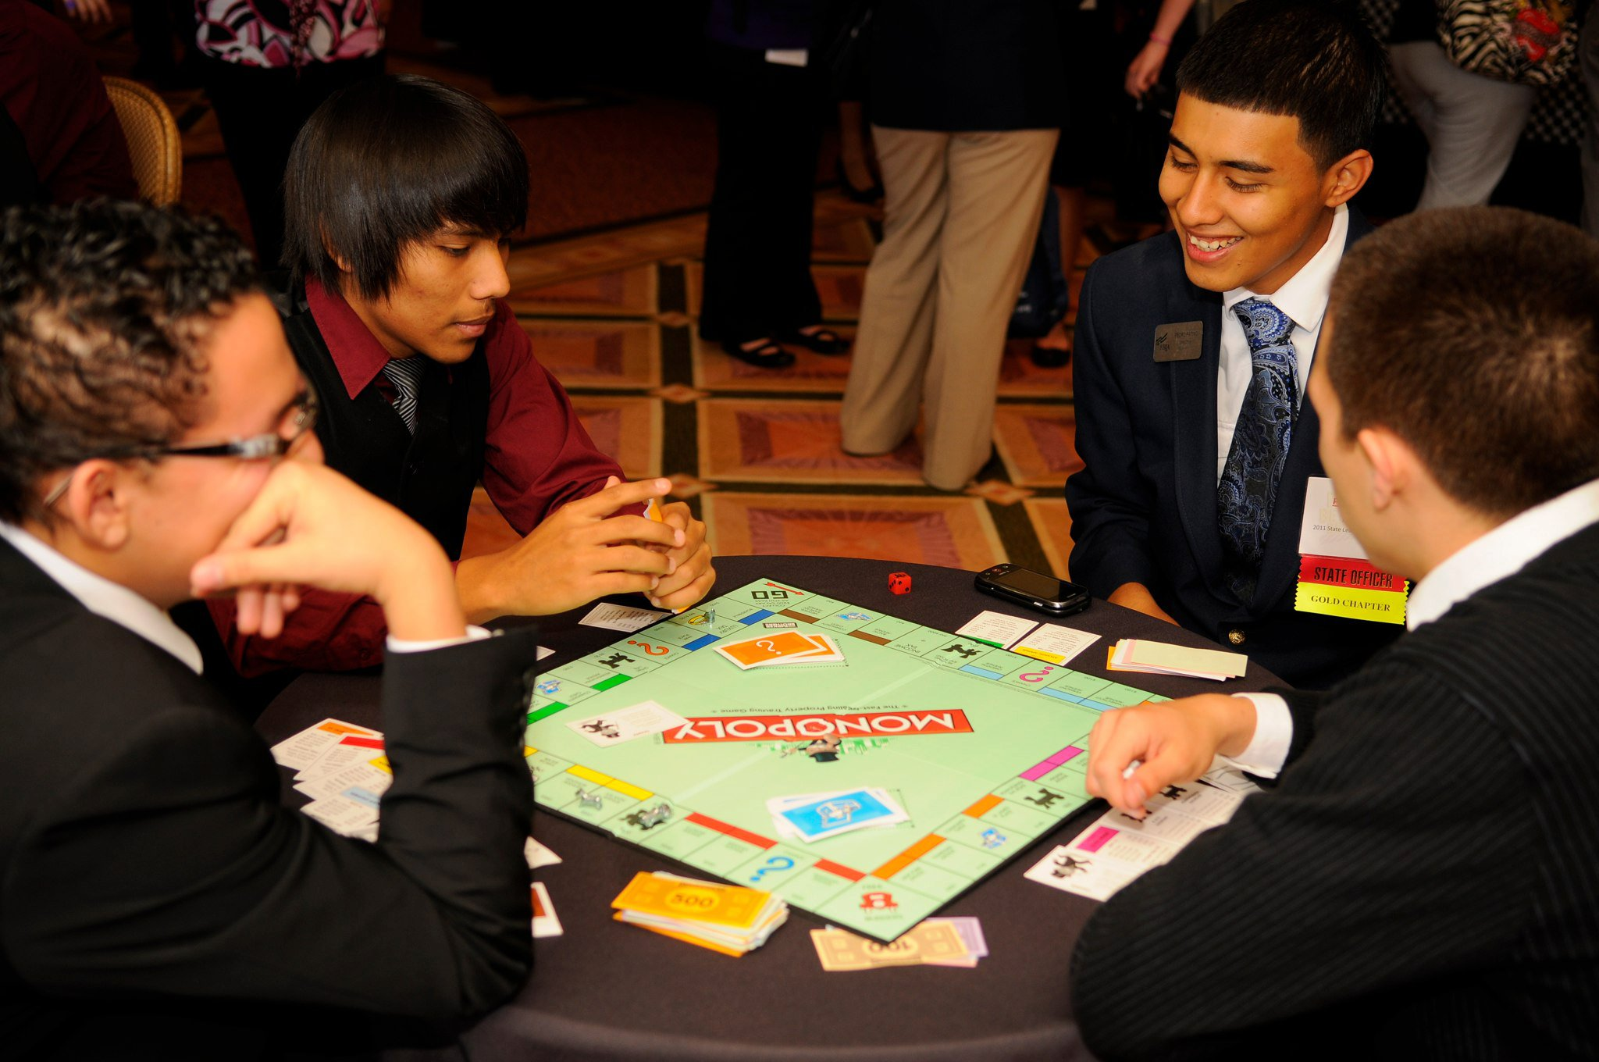
Camp: ALAFCCLA Showcase is the destination to experience at this year’s State Leadership Conference! Whether you just finished your competition, have some down time before the next workshop, or are just looking to meet more members and connect with outstanding leaders, the Camp: ALAFCCLA showcase is the go-to spot at this year’s SLC! This event includes fun, hands-on leadership activities including The Art of Leadership, Creative and Interactive Game Stations, Appreciation Station, Wii games, JUST DANCE! And much more!

Election of Alabama FCCLA State Officers
During the State Leadership Conference, members will have the opportunity to run for an office on the 2019-2020 State Executive Council. All members that are dedicated to ALAFCCLA, have served as a chapter officer or committee member, have a passion for leadership, and enjoy working with others to improve the organization are encouraged to run for office. Please consult the ALAFCCLA State Officer Candidate Guide for a list of eligibility requirements. Being a State Officer for the Alabama Association of FCCLA is an incredible honor.

Each candidate must complete the 2019-2018 ALAFCCLA State Officer Candidate Application, which can be found on the Alabama FCCLA website under “State Officers.” The application must be submitted, via email to ehicks2@alsde.edu, by January 15, 2019. Each chapter may submit one state officer candidate application.

Qualifications of officer candidates will be enclosed in the chapter registration materials on-site. Advisers are encouraged to review the materials with your chapter officers and members. All elections will be held Thursday evening during the Opening Session.

Voting Delegates
Chapters must assign a voting delegate(s) to cast votes for the State Executive Council election. The number of voting delegates is determined by the number of paid members within the chapter in the current year. One delegate is assigned for the first 40 members or less. One additional delegate is assigned for each additional 40 members or a major fraction thereof (more than 1/2).

Middle school chapters that affiliate through the Chapter Fee program are assumed to have 50 members and will have one delegate for the first 50 members. There will be one additional delegate assigned for each additional 50 members or a major fraction thereof (more than 1/2).

Chapters affiliated through the Urban Fee program will be allocated one delegate per school.

Chapter Banner Parade
Each year, ALAFCCLA’s Chapter Banner Parade benefits a community service project. This year the community service initiative we will be supporting during our ALAFCCLA Banner Parade is “Read to Succeed”. Chapters who participate in this project and attend the ALAFCCLA State Leadership Conference March 14-15, 2019 in Montgomery, AL, will be invited to participate in the Banner Parade.

This is how the Read to Succeed community service project works. It is a book donation project for newborns through one year old babies born in the year of 2018. Here is how you can participate in the state community service project! The first thing you should do is contact your local hospital to get the average number of babies born in a year or contact your local media and make them aware of what you are doing, provide them with the name of your chapter name and organization, and let the families in your community contact you if they have just had a baby or are about to have one. After you get the total number of babies born in a year, you can determine how many books your chapter will donate. Your chapter should then collect new or lightly used and in good condition books to donate along with letters that the chapter members have written on how they as an Alabama Association of FCCLA member recognizes the importance of family and reading.

ALAFCCLA Chapters that participate in this project will need to submit the name of their chapter, the number of books donated, and a picture of the chapter members donating the books by January 15, 2019 to Esther Hicks at ehicks2@alsde.edu. Only chapters who have participated in the state project and attend the ALAFCCLA State Leadership Conference March 14-15, 2019 in Montgomery, AL, will be invited to participate in the Banner Parade. Chapters will not bring the books to the state conference; they should be donated directly to the hospital or family in the community where the chapter is located. When donating the books, please let the recipients know the name of the organization and the name of your chapter.

Leadership & Career Development Workshops
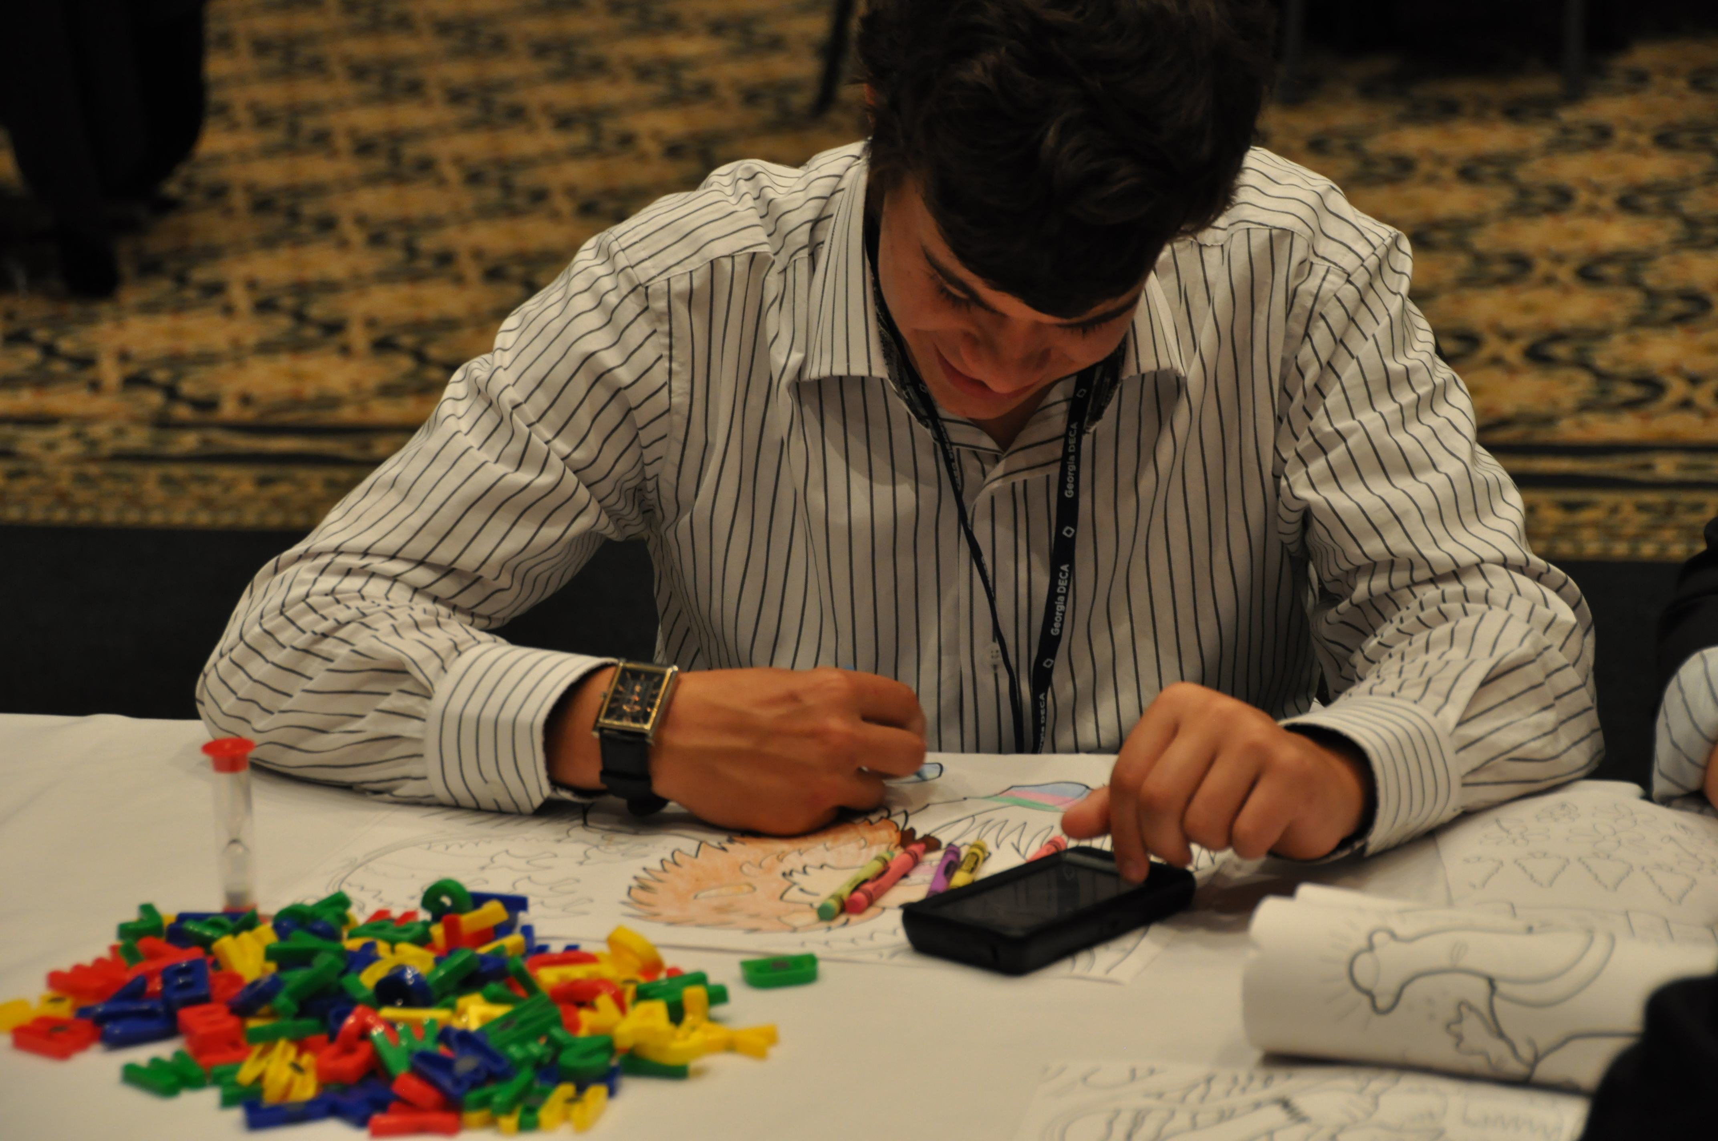
Camp: ALAFCCLA is the place to have The Ultimate Leadership Experience…so come and experience some awesome, engaging, inspiring, and educational workshops! This year’s SLC includes an expanded slate of workshop offerings to provide more opportunities for members to develop their leadership skills and prepare for future careers.

National Programs & Recognition Awards
Alabama Association of FCCLA is proud to present the following awards as part of the Opening Session. Each award recipient will be recognized on stage unless noted with an asterisk, in which case they will stand for recognition.

National Programs | Other Awards
State winners in:  - Spirit of Advising  - Power of One* | - ALAFCCLA Scholarship Recipient  - Alabama Champion Chapters*  - Alabama Children’s First State Project  - Focus on Alabama  - Golden Chapters*  - iRecruit! Membership Increase Award*  - 100% Membership*  - Prescription to Healthy Living

The Closing Session will include the following awards:

- ALAFCCLA STAR Event Awards
- Instillation of the 2019 – 2020 ALAFCCLA State Officers
REMINDER: Applications for all state and national awards are due to the state office by January 15, 2019.

All national program awards must be submitted directly to National FCCLA by the local chapter adviser using the online affiliation system to be considered for a national award. To apply for the national program state awards, the application should be submitted to National FCCLA through the FCCLA affiliation system. More information on the national FCCLA website at http://fcclainc.org/programs/program-award-applications.php

The state-only awards (ALAFCCLA Scholarship Recipient, Alabama Champion Chapters, Alabama Children’s First State Project, Focus on Alabama, Golden Chapters, iRecruit! Membership Increase Award, 100% Membership, and Prescription to Healthy Living) should be sent directly to the state office by January 15. All national program award applications must be sent to the national office, as well as a copy being sent to the state office so we know who submitted an application.

STAR Events
STAR Events (Students Taking Action with Recognition) are competitive events in which members are recognized for proficiency and achievement in chapter and individual projects, leadership skills, and career preparation. STAR Events offer individual skill development and application of learning through the following activities:
- Cooperative - teams work to accomplish specific goals
- Individualized - an individual member works alone to accomplish specific goals
- Competitive - individual or team performance measured by an established set of criteria.

Alabama FCCLA will be offering the following STAR Events as part of the 2018 SLC. Note Alabama does not offer all National FCCLA’s STAR Events and below are the only events offered in Alabama.
• Advocacy  • Applied Math in Culinary Management  • Career Investigation  • Chapter Service Project Portfolio  • Culinary Arts  • Early Childhood Education  • Entrepreneurship  • Environmental Ambassador  • Fashion Construction  • Fashion Design  • Focus on Children  • Food Innovations  • Hospitality, Tourism and Recreation | • Illustrated Talk  • Interior Design  • Interpersonal Communications  • Job Interview  • Leadership  • Life Event Planning  • National Programs in Action  • Nutrition and Wellness  • Promote and Publicize FCCLA  • Recycle and Redesign  • Say Yes to FCS Education  • Sports Nutrition  • Teach and Train
Each student is eligible to compete in one (1) event, including Culinary Arts. Each chapter can have one entry (individual or team) per event category.

A final STAR Event schedule, including days and times of events, will be released prior to the conference, after registration has closed. Culinary Arts will be held during the SLC on March 14-15 at an off-site facility.
Be sure to follow the 2018-2019 Competitive Events Guide as all STAR events will be conducted in accordance with National FCCLA guidelines. Chapter advisers may access and download the Guide from the “Resources Tab” in the National FCCLA Portal. You can find more STAR Event national resources at http://fcclainc.org/programs/resources.php.

Keynote Speaker
Alabama FCCLA is in the process of securing a dynamic and inspiring keynote speaker to headline the Opening Session. Stay tuned to Alabama FCCLA’s social media and website for the announcement of this year’s keynote speaker.

Culinary Arts Details
Each chapter will develop their own menu and submit the menu to the state office no later than February 1, 2019 by 5:00 PM. The menu should be submitted to Esther Hicks at ehicks2@alsde.edu. The overall winner of the State ALAFCCLA Culinary STAR Event will be invited to participate at the FCCLA National Leadership Conference Culinary STAR Event in Anaheim, CA. The menu chosen for the Culinary Arts competition at National Leadership Conference will be selected by National FCCLA and may be found on their Web site once they have been posted.

REGISTRATION RESOURCES

Registration Reminders
Registration Link https://www.registermychapter.com/fccla/al
Registration Deadline Friday, February 1, 2018 (5:00 p.m. central)
Hotel Cut-Off Date Wednesday, February 8, 2019 or until sold out
Payment Due Date February 15, 2019 to Alabama FCCLA Business Office
Late Registration Not Accepted
Hotel Registration (334) 481-5000

Registration Fee
The conference registration fee is $40 per attendee, including students, advisers, chaperones, and guests. Registration for current state officers is complimentary. The registration fee includes:
- Keynote speaker
- Leadership programming
- General session multimedia production
- Registration services
- Event resources (conference program, name badges, facility access, materials, etc.)
- STAR Event materials (printing, awards, etc.)
- Conference t-shirt
Name badges must be worn by all participants to be able to gain access to all activities of the conference including, but not limited to the following workshops, STAR Events, exhibit areas, opening and closing ceremonies, etc. No one will be allowed to enter any of the ALAFCCLA Event areas without a name badge. Those who will only be attending the opening and/or closing sessions will have special badges for easy identification. These tickets must be purchased at the through the local chapter adviser by the registration deadline Friday, February 1, 2019.

Accommodations
Chapter advisers can secure rooms at our official conference hotel – the Renaissance Montgomery Hotel & Spa at the Convention Center. These rooms will be available on a first-come, first-serve basis. Advisers are responsible for securing their own accommodations during the event.

It is the official policy of Alabama FCCLA that all conference attendees must stay at the conference hotel (assuming space is available), with the exception of those schools that are within a 50-mile radius of Montgomery. See the enclosed mileage chart for reference.

It is extremely likely our room block at the Renaissance Montgomery will fill up quickly. In this case chapters can secure their own lodging at nearby hotels. Alabama FCCLA has not negotiated a hotel room rate with any property other than the Renaissance Montgomery.

Renaissance Montgomery Hotel & Spa at the Convention Center
201 Tallapoosa Street
Montgomery, AL 36104
Phone: (334) 481-5000
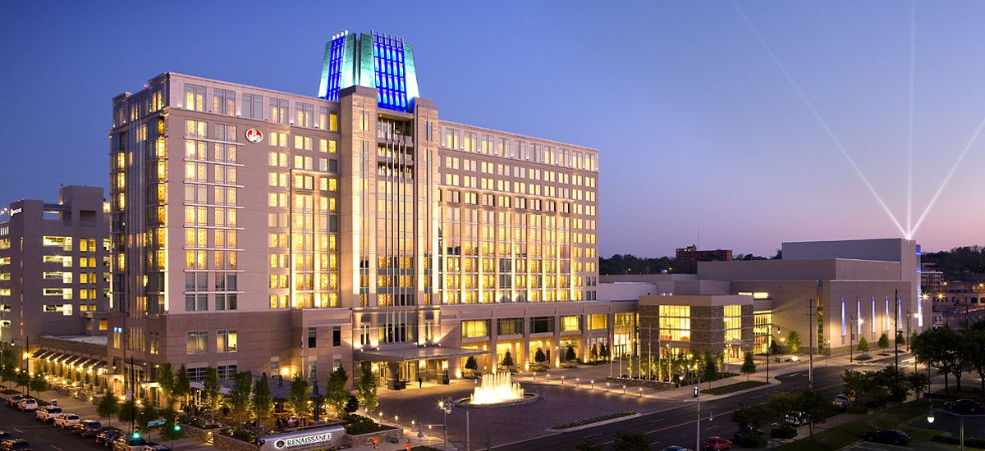

Parking for regular vehicles is available for a fee in the Montgomery Renaissance Hotel deck. We are working with the Montgomery Area Chamber of Commerce Convention & Visitor Bureau and the Montgomery Police Department to assist with bus parking this year. Additional information about bus parking will be emailed to you as we get closer to the conference.

MILEAGE CHART FROM MONTGOMERY AL, TO LISTED DESTINATION:
Abbeville | 97 | Dadeville | 63 | Hope Hull | 9 | Ozark | 82
Akron | 121 | Daleville | 97 | Hueytown | 97 | Pelham | 72
Alabaster | 69 | Dannelly Field | 10 | Huntsville | 193 | Pell City | 103
Albertville | 151 | Danville | 170 | Hurtsboro | 65 | Phenix City | 82
Alex City | 53 | Deatsville | 25 | Jackson | 135 | Phil Campbell | 179
Aliceville | 148 | Decatur | 174 | Jackson Gap | 67 | Piedmont | 135
Andalusia | 87 | Demopolis | 100 | Jacksonville | 123 | Pine Apple | 68
Annemani | 96 | Dothan | 106 | Jasper | 132 | Pine Hill | 93
Ann Jordan Lodge | 67 | Double Springs | 156 | Jemison | 53 | Plantersville | 55
Anniston | 110 | Dozier | 69 | Joe Wheeler St. Park | 211 | Point Aquarius | 91
Arab | 158 | Eclectic | 31 | Kellyton | 52 | Point Clear | 180
Ariton | 73 | Elba | 79 | Kennedy | 152 | Prattville | 15
Ashford | 116 | Elmore | 18 | Killen | 221 | Prattville Exit | 8
Ashland | 78 | Enterprise | 85 | Kinston | 91 | Red Bay | 211
Ashville | 120 | Equality | 36 | Lafayette | 78 | Reel Town | 43
Athens | 188 | Eufaula | 84 | Lanett | 81 | Reform | 135
Atmore | 122 | Eufaula Lake Point | 90 | Langdale | 83 | Riverside | 103
Attalla | 134 | Eutaw | 121 | Letohatchee | 24 | Roanoke | 94
Auburn | 56 | Evergreen | 78 | Lincoln | 98 | Robertsdale | 176
Autaugaville | 25 | Fairfield | 103 | Linden | 100 | Robinson Spring | 13
Bay Minette | 146 | Fairhope | 178 | Lineville | 85 | Rockford | 44
Bear Creek | 173 | Fayette | 144 | Livingston | 126 | Rogersville | 204
Belgreen | 198 | Flomaton | 122 | Loachapoka | 51 | Russellville | 190
Bessemer | 93 | Florala | 104 | Luverne | 51 | Salem | 69
Billingsley | 38 | Florence | 212 | Marbury | 30 | Samson | 104
Birmingham | 93 | Foley | 186 | Marion | 82 | Scottsboro | 189
Blountsville | 140 | Fort Deposit | 35 | McCalla | 100 | Seale | 86
Boaz | 145 | Fort Payne | 168 | McIntosh | 159 | Selma | 50
Brantley | 60 | Gadsden | 129 | McKenzie | 69 | Sheffield | 210
Brent | 70 | Geneva | 108 | Mellow Valley | 78 | Shorter | 23
Brewton | 105 | Georgiana | 61 | Midfield | 99 | Slocomb | 104
Bridgeport | 216 | Geraldine | 166 | Midland City | 97 | Smiths Station | 81
Brilliant | 169 | Glencoe | 123 | Midway | 58 | Springville | 123
Brundidge | 60 | Goodwater | 58 | Millbrook | 10 | Sulligent | 175
Butler | 135 | Gordo | 127 | Millport | 154 | Sumiton | 116
Bynum | 107 | Goshen | 63 | Millstead | 27 | Sweet Water | 112
Calera | 59 | Grant | 175 | Mobile | 173 | Sylacauga | 64
Camden | 73 | Greenville | 45 | Monroeville | 107 | Talladega | 86
Camp ASCCA | 72 | Greensboro | 100 | Montevallo | 65 | Tallassee | 34
Carbon Hill | 147 | Grove Hill | 119 | Moulton | 175 | Tarrant | 103
Carrollton | 140 | Guin | 169 | Moundville | 114 | Theodore | 181
Centre | 152 | Gulf Shores | 197 | Mount Meigs | 13 | Thomasville | 105
Centreville | 68 | Guntersville | 160 | Mount Vernon | 173 | Thorsby | 46
Chatom | 160 | Guntersville St. Pk | 168 | Mountain Brook | 93 | Troy | 48
Cheaha St. Park | 99 | Haleyville | 167 | Muscle Shoals | 208 | Trussville | 108
Cherokee | 225 | Hamilton | 182 | Natural Bridge | 158 | Tuscaloosa | 104
Childersburg | 76 | Hanceville | 134 | New Brockton | 81 | Tuscumbia | 208
Citronelle | 188 | Hanover | 52 | Newton | 91 | Tuskegee | 42
Clanton | 39 | Hartford | 103 | Newville | 115 | Union Springs | 44
Clayton | 72 | Hartselle | 161 | Northport | 106 | Union town | 80
Cleveland | 133 | Hayden | 121 | Notasulga | 46 | Verbena | 32
Clio | 73 | Hayneville | 23 | Oakman | 143 | Vernon | 164
Collinsville | 153 | Headland | 108 | Odenville | 114 | Wedowee | 102
Columbiana | 68 | Heflin | 111 | Oneonta | 130 | West Blocton | 83
Cottonwood | 120 | Highland Home | 31 | Opelika | 62 | Wetumpka | 17
Courtland | 188 | Holtville | 27 | Opp | 83 | Winfield | 162
Cuba | 135 | Hollywood | 193 | Orange Beach | 192 | Winterboro | 76
Cullman | 141 | Homewood | 89 | Orrville | 66 | York | 132
 |  |  |  | Oxford | 107

Registration Procedures & Reminders
The SLC registration system is integrated into National FCCLA’s membership affiliation system, meaning to register for the conference, the attendee must be a paid member of FCCLA. FCCLA affiliation is automatically checked through the online system before the conference. However, registration is through a separate site from the affiliation system. To affiliate with National FCCLA, you must go through the National FCCLA Web portal and have your payment to them before February 1, 2019.

- ALAFCCLA conference payment must be made in advance of the event to the Alabama FCCLA Business Office. The mailing address is P.O. Box 1440, Owasso, OK 74055.

Every attendee will receive the official conference t-shirt as part of your registration. Advisers will select t-shirt sizes when you register for the conference.

Name badges must be worn by all participants to be able to gain access to all activities of the conference including, but not limited to the following workshops, STAR Events, exhibit areas, opening and closing ceremonies, etc. No one will be allowed to enter any of the ALAFCCLA Event areas without a name badge. Those who will only be attending the opening and/or closing sessions will have special badges for easy identification. These tickets must be purchased at the through the local chapter adviser by the registration deadline Friday, February 1, 2019.

Forms and Important Documents
All student participants must sign the Permission/Participant Form, and all advisers must fill out the Adviser Statement of Assurance Form. Advisers must have a completed copy of the Permission/Participant Form for each student attending in their possession for the duration of the event, including travel to and from the event. Adviser Statement of Assurance Forms must be submitted on-site at registration. All forms are available on the National FCCLA Web site.

The Alabama FCCLA W-9 form is available for download on the Alabama FCCLA Web site. Please share this information with school bookkeepers.

Special Needs
The special needs request form is enclosed so that arrangements can be made to aid any member with special needs.

Dress Code
FCCLA members and advisers are representing an outstanding student organization and should project the image of a leader. During the conference, members, advisers and guests are expected to remember the following guidelines listed below in relation to their conference attire. It should be noted that the official FCCLA uniform is always acceptable and encouraged for members and advisers during FCCLA events. Members, advisers, chaperones, and guest not in proper attire will not be admitted into the event areas including, but not limited to the following opening and closing ceremonies, STAR Events, exhibits, workshops, and etc.

Dress Attire | Men | Women
Student:  General Sessions, Meetings, Workshops, Exhibits, STAR Events, Etc. | - Red Blazer  - Encouraged at SLC, not required  - Required at NLC  - White Oxford Shirt or White/Red Polo  - Red/Black Tie  - Black Dress Pants  - Black Belt/Socks  - Black Dress Shoes | - Red Blazer  - Encouraged at SLC, not required  - Required at NLC  - White Oxford Shirt or White/Red Polo  - Red or Black Tie/Ascot/Single Strand Pearls  - Black Dress Pants/ Skirt/ Black Sheath Dress  - Nude Nylons  - Black Closed-Toe Dress Shoes
Advisers / Guests:  General Sessions, Meetings, Workshops, Exhibits, STAR Events, Etc. | - Dress shirt, necktie, slacks, blazer – or suit – with dress shoes and socks  Or  - Red Blazer  - Encouraged at SLC, not required  - White Oxford Shirt or White/Red Polo  - Red/Black Tie  - Black Dress Pants  - Black Belt/Socks  - Black Dress Shoes | - Business dress or suit, dress pants, dress shirt, nylons and closed-toe shoes  Or  - Red Blazer  - Encouraged at SLC, not required  - White Oxford Shirt or White/Red Polo  - Red/Black Tie  - Black Dress Pants  - Black Belt/Socks  - Black Dress Shoes
Casual:  Travel to and from FCCLA functions, recreational tours, theme parks, and other casual activities | - Longer-length shorts/casual slacks  - Collared shirt, sweatshirt, t-shirt  - Casual footwear  - NO flip flops  - Nice Denim – is acceptable | - Longer-length shorts/casual slacks  - Collared shirt, sweatshirt, t-shirt  - Casual footwear  - NO flip flops  - Nice Denim – is acceptable

Adviser Reminders
As leaders and teachers of young professionals, it is important that we prepare our students for this upcoming event. The following information will help you to plan for the State Leadership Conference (SLC) and prepare your students with important information about the conference.

Curfew
While attending the conference, please keep in mind this event has a curfew of 11:00 PM. Therefore, be mindful of this curfew when taking your students out for the evening. In addition, please make sure that there are no pizza deliveries after curfew, no running to the soda machine, or chapter meetings in an adviser’s room running so late that students will be in the hall after curfew. As an adviser, please do your part to help make the system work for the benefit of everyone. Please plan for your chapter meetings and any late-night food supplies for your students within curfew requirements.

We all need to work together to keep the noise level in the hallways down during all hours. Remember there are other guests besides those with our organization.

Chapter advisers are responsible for the conduct of their chapter members. Unfortunately, simply checking to make sure your students are in their rooms at curfew does little to ensure they will stay there. Therefore, advisers should be visible in each hall for at least one hour past the published curfew.

Onsite Chaperoning
Having your students check in with you at least three times per day is recommended. Let your students know your whereabouts so they can easily do this. Have your students work together to remind each other of the times and locations for their events and activities. When you are busy assisting with an activity, make sure you let your students know where your assignment will be and have them write it down in their programs.

Remind students to thank the event staff, judges, and volunteers. They appreciate knowing their hard work has benefited the students. If you plan to use parent chaperones, encourage your officers to plan a special way to thank them at the conference or upon returning home.

Visibility
Drop in and check on your students. Performing a "head count" at curfew time is vital. Be sure to physically see every student at curfew. Ask questions about events and have a conversation with them so you can see how things are going.
Publicity
Your chapter and Alabama Association of FCCLA, in general, welcome positive publicity. Use participation for the SLC to generate some positive publicity. It is always nice for the public to know you have participated before you must earn dollars for the national competition.

Adviser Assignments
This year we will again need your assistance with STAR Events. Please be prepared to serve as a Lead Consultant or assistant and etc. If you are bringing chaperones, we could use their assistance as well. Assignments will be sent prior to the conference via email and posted to the Alabama FCCLA website. Your support will continue to ensure a smooth-running conference.

Pre-Registration Checklist
Information Needed for Registration Form

When registering your chapter for State Leadership Conference, the following information should be readily available:
- Membership Dues have been paid to National FCCLA for each student attending SLC
- Chapter member’s first and last name
- T-Shirt Size
- Grade in School
- Gender
- Membership Status
  - Junior – Grades 9 and below
  - Senior – Grades 10 through 12
  - Occupational – Grades 10 through 12
- Competitive events in which member is competing
- List of guests or chaperones
- Names of voting delegates
We encourage you to have all participants complete the Pre-Online Registration Form to help streamline your registration process.

Registration Guide
All registrations must be submitted electronically, via Register My Chapter; access online registration by visiting https://www.registermychapter.com/fccla/al.

- In your web browser, go to the website that you were given for registration. A screen similar to the following screen should appear:

- Click the Registration button to begin registration. You will be asked to log in. You will be required to log in using the user name and password that is used for your National FCCLA online affiliation portal. There will be a link below the user name and password that you can click to add your chapter.

- The first time in, you will be asked to verify your school information. Double check all the fields and press the Submit button at the bottom to save any changes.

- Your name will automatically be added to the list as an adviser.

- Click the Add New Name button to add a new name to the list. Provide the participant’s last name and first name and select their status from the drop-down list. Be sure to check the event that this individual will participate in.

- To enter team events, be sure to select the correct team number. The number should be 1 for the first team for this event, and 2 for the 2nd team for this event, etc.

- Continue adding names until you have entered all of your students. If you attempt to enter more students in an event than are allowed, you will be informed and not allowed to exceed the event maximum. At any point, you may press the View Registration button to get an idea of your total invoice amount and a better understanding of who is registered for which events.
- When you are finished, press the Finished Registering button at the bottom. At this point, you may have several red messages at the top of the screen. Please read these carefully. Your registration will not be complete until these problems have been resolved. To correct this problem, click the Back to Registration link at the bottom. Select the student you may be having registration problems with and click the Edit link beside that student. Change the information you need to change and press Submit to save. When you’re finished making these changes, press the Finished Registering link again.

- If you get a message that states that you have not met the minimum requirements for an event, then you must click the Back to Registration link and either add students to those events that are short or remove students from those events that are over the limit. When you’re finished making those changes, press the Finished Registering button again.

- When you have corrected any problems that may have appeared, Print a copy of this tentative invoice from the Finished Registering screen. Next, press the Confirm link at the bottom to confirm that the tentative invoice is correct. You will receive an invoice via separate email to submit to your school for payment.

- If you need to edit your registration, you may come back to this location and make changes until Friday, February 1, 2019 at 5:00 pm. After that date/time, no more changes may be made.

- To make changes, click on the Registration button at the left. After logging in, the list of Registered Individuals will appear. Simply click the Edit link and make any changes you need. When you do this, remember to press the Finished Registering button to check for problems and to resubmit the invoice.

- Once you are finished with your registration, be sure to either click the Log Out link to make sure that the connection is securely closed or exit your browser. This will ensure that no one can get in and make changes to your registration.

Registration Tips
- Avoid Common Registration Frustrations! Read this registration packet in detail! Assign it for extra credit to chapter officers to ensure that multiple members of your chapter are familiar with SLC requirements and procedures.
- Read the FCCLA Competitive Events Guide 2018-2019 edition (STAR Events). Additions to this guide have been made, so please ensure you are using the most up-to-date information when preparing for Competitive Events. The STAR Events Guide is available through the affiliation portal.
- Follow-up with the district or business office to ensure the invoices will be paid on time. Payment should be postmarked by February 15, 2019 or your local chapter will be mailed a late charge invoice for $25.00 from the Alabama FCCLA Business Office.
- Photocopy all forms and correspondence for your records and bring them to SLC!
- Make registration checks payable to: Alabama FCCLA Business Office. The mailing address is P.O. Box 1440, Owasso, OK 74055.
- Carefully review the Alabama FCCLA Dress Code Policy and Code of Conduct standards with your students before you arrive for the SLC.
- E-mail all questions to ehicks2@alsde.edu.

Judges Needed
The Alabama Association of FCCLA Competitive Events Program requires an extraordinary amount of effort, work, and volunteer spirit to be successful and truly prepare students for career achievement. Teacher who have students participating in STAR Events will be required to assist at the state leadership conference. They may be assigned to be a judge, STAR Event Coordinator, room coordinator, and etc. If you have chaperones, business contacts, and colleagues that are willing to judge events, please email ehicks2@alsde.edu with the name, phone number, and email address of each volunteer. We will contact them with follow-up information.
2019 FCCLA STATE LEADERSHIP CONFERENCE AND STAR EVENTS

REQUEST FOR SPECIAL SERVICES

Please complete the following information for any member requiring special services in order to successfully participate in the Alabama Association of FCCLA State Leadership Conference STAR Events. Send forms by February 1, 2019.

SCHOOL: _____________________________________________________________________________________________

ADVISER: ___________________________________________ PHONE: _______________________________________

FAX : _____________________________________ E-MAIL: ____________________________________________________

Student Member: _____________________________________________________________________________________

State Conference: _____________________________________________________________________________________

Special Needs: ________________________________________________________________________________________

____________________________________________________________________________________________________

Competitive Event: ____________________________________________________________________________________

Special Needs: ________________________________________________________________________________________

____________________________________________________________________________________________________

I certify that the above special needs identified for _______________________________________________, is
in compliance with the Individualized Education Program (IEP) on file for this student. The student will have
the opportunity to participate in non-academic/extracurricular activities with his/her nondisabled peers.

Yes, without support.
Yes, with support.

Describe support as identified on the student’s IEP: __________________________________________________________

____________________________________________________________________________________________________

_____________________________________________________ ______________________________________
Adviser Signature Date

PERMISSION/PARTICIPANT FORM – ALABAMA FCCLA SLC 2019 (3 PAGES TOTAL)
CODE OF CONDUCT

Attendance at Alabama FCCLA SLC is a privilege. The following conduct policies will apply to all delegates: students, advisers, and any other authorized persons attending the activity. This form must be signed by each student (under 21) attending Alabama FCCLA SLC and submitted to the chapter adviser prior to the conference. The chapter adviser must have a completed copy of the permission/participant form for each student attending in their possession for the duration of the event, including travel to and from the event. Forms must be kept on file in the local school district after the conference.

Delegates shall abide by the rules and practices of Alabama FCCLA and school district policies at all times to, during, and from the designated point of origin of the activity. Delegates shall respect and abide by the authority vested in the Alabama State Department of Education/Alabama FCCLA. The standards outlined in this document constitute the Alabama FCCLA Code of Conduct.

The following shall be regarded as severe violations of the Alabama FCCLA Code of Conduct:

Should a conduct code violation occur for item 1 through 7 below, regardless of when exposed, the violating student(s) will be sent home. If the violation warrants it, law enforcement may also be notified. Determination of penalties for violations will be at the discretion of Alabama FCCLA.

- Alcohol, Drugs and Tobacco: a student shall not possess, use, transmit, be under the influence of, or show evidence of having used an alcoholic beverage, other drugs, substances or tobacco products capable of or intended, purported, or presumed to be capable of altering a student's mood, perception, behavior or judgment; other than properly used, over-the-counter pain relievers and medications prescribed by a physician for an individual student and must be on record with the adviser. Nor shall the student possess, use, sell or transmit paraphernalia associated with drugs, alcohol, or chemical substance in any form (including tobacco), at any time, or under any circumstances, on public or private properties.
- Curfew: Committing serious violations of curfew regulations as outlined in item 8 below.
- Willful Companionship: Being in the willful companionship of someone who violates any portion of the conduct code, or failing to report any direct knowledge (other than hearsay) of the conduct code violations.
- Personal Conduct: Cheating, dishonesty, or taking unfair advantage of others; participating in social activities other than those with conference participants; conducting acts and/or possession of weapons capable of causing bodily harm or fear of life, defacing or stealing any public or private property (for which financial responsibility will rest solely with offending individuals or their chapter); breaking the law; other serious violations of personal conduct regulations.
- Serious Violations of the student conduct code of the school district or school that the student represents.
- Abusive Behavior and Lewd Conduct: A student shall not engage in any lewd, indecent, sexual, or obscene act or expression or possess such materials. A student shall not engage in verbal, physical or sexual harassment, hazing, or name-calling. The use of slurs against any person on the basis of race, color, creed, national origin, ancestry, age, sex, sexual orientation, or disability is prohibited.

The following shall be other violations of the Alabama FCCLA Code of Conduct:
Should a conduct code violation occur for items 7-12 below, regardless of when exposed, the violating student(s) may be sent home. Determination of penalties for violations will be at the discretion of Alabama FCCLA or local Adviser.

- Conference Conduct: Failing to wear the supplied conference name badge at all times from arrival at the conference until departure at the end of the conference; leaving sessions prior to their conclusion (except in the case of emergency); failing to attend all general sessions and assigned activities for which a delegate is registered; not abiding by the rules and regulations of Alabama FCCLA or school/district policies from the time he/she leaves his/her home or school for any activity and the time he/she returns to the same home or school following the activity.
- Curfew (when applicable): Failing to be in your assigned hotel room from the curfew time designated in the conference program until 6 a.m.; causing any noise or other disturbance audible by anyone in the hallway after designated curfew time; ordering any food after the designated curfew time; causing any other unnecessary disturbance or participating in any other inappropriate activity after the designated curfew time.
- Dress: Failing to abide by the dress regulations established for the conference, as outlined in the Dress Code.
- Personal Conduct: Failing to report accidents, injuries or illnesses immediately to the local Adviser; failing to keep adult advisers informed of activities and whereabouts at all times; using tobacco products outside of local school district policies and state law; having a member of the opposite sex in a room if no adult chaperone is present and the room door is not visibly open (e.g. the door may be propped wide open); having a delegate or adviser of the opposite sex in a room without a third person present and the door visibly open.
- Hotel Conduct: Failing to meet the professional standards of housing facilities; accruing incidental room charges (i.e. phone calls, room service, pay-per-view movies, etc.) without settling the account prior to check-out; throwing objects out the window or into the hallway; moving hotel furniture from rooms (e.g., onto the balcony); failing to follow hotel rules and regulations.

Individual School District Policies may supersede the code of conduct.

DRESS CODE FOR DELEGATES ATTENDING ALABAMA FCCLA SLC

The following guidelines have been developed to clarify the dress code used at FCCLA SLC.
Dress Attire | Men | Women
Student:  General Sessions, Meetings, Workshops, Exhibits, STAR Events, Etc. | - Red Blazer  - Encouraged at SLC, not required  - Required at NLC  - White Oxford Shirt or White/Red Polo  - Red/Black Tie  - Black Dress Pants  - Black Belt/Socks  - Black Dress Shoes | - Red Blazer  - Encouraged at SLC, not required  - Required at NLC  - White Oxford Shirt or White/Red Polo  - Red or Black Tie/Ascot/Single Strand Pearls  - Black Dress Pants/ Skirt/ Black Sheath Dress  - Nude Nylons  - Black Closed-Toe Dress Shoes
Advisers / Guests:  General Sessions, Meetings, Workshops, Exhibits, STAR Events, Etc. | - Dress shirt, necktie, slacks, blazer – or suit – with dress shoes and socks  Or  - Red Blazer  - Encouraged at SLC, not required  - White Oxford Shirt or White/Red Polo  - Red/Black Tie  - Black Dress Pants  - Black Belt/Socks  - Black Dress Shoes | - Business dress or suit, dress pants, dress shirt, nylons and closed-toe shoes  Or  - Red Blazer  - Encouraged at SLC, not required  - White Oxford Shirt or White/Red Polo  - Red/Black Tie  - Black Dress Pants  - Black Belt/Socks  Black Dress Shoes
Casual:  Travel to and from FCCLA functions, recreational tours, theme parks, and other casual activities | - Longer-length shorts/casual slacks  - Collared shirt, sweatshirt, t-shirt  - Casual footwear  - NO flip flops  - Nice Denim – is acceptable | - Longer-length shorts/casual slacks  - Collared shirt, sweatshirt, t-shirt  - Casual footwear  - NO flip flops  - Nice Denim – is acceptable

Members, advisers, chaperones, and guest not in proper attire will not be admitted into the event areas including, but not limited to the following opening and closing ceremonies, STAR Events, exhibits, workshops, and etc.

ALABAMA FCCLA SLC 2019 PERMISSION FORM

Student Name: ___________________________________ School: ___________________________________

This is to certify that the above named delegate has my permission to attend Alabama FCCLA SLC. I also do hereby, on the behalf of the above named delegate absolve and release Alabama FCCLA, the school officials, the chapter advisers, conference staff, and Alabama FCCLA staff from any claims for personal injuries/damages which might be sustained while he/she is en route to and from or during the FCCLA sponsored activity.

I authorize the above named adviser or the Alabama FCCLA staff to secure the services of a doctor or hospital for the above named delegate. I will supply a copy of my insurance card for my child and will incur expenses for necessary services in the event of accident or illness and provide for the payment of these costs.

I grant permission to Alabama FCCLA and its staff/contractors, Alabama State Department of Education, Alabama CTE Leadership Council, and sponsors/supporters to use the above delegate’s name and likeness (including photographs, video footage, silhouettes, and audio clips) in publications, productions, promotions and on websites for informational, promotional and other related purposes without further consideration, and acknowledge the right of Alabama FCCLA to crop, treat, edit, or otherwise modify the photographs, video footage, silhouettes, and audio clips at their discretion.

We have read and agree to abide by the supplied Alabama FCCLA Code of Conduct. Should a code of conduct violation occur, law enforcement personnel and or security may be called to assist, and a conduct code committee may be called with the ultimate punishment being that the student may be sent home at their/their family’s expense. If the delegate is sent home reasonable care shall be exercised to ensure a safe, expedient, and financially feasible mode of transportation back to the home community of the delegate involved. We are aware of the consequences that will result from violation of any of the above guidelines.

Student Signature ___________________________________ Date ______________________________

Parent / Guardian Signature ___________________________ Date ______________________________

Chapter Adviser Signature _____________________________ Date ______________________________

STATEMENT OF ASSURANCE – ALABAMA FCCLA SLC 2019

Advisers attending Alabama FCCLA SLC must review, sign, and turn in this statement of assurance in order to receive their registration materials on-site at SLC.

As the adviser responsible for the students attending this event I confirm that:
- I have reviewed the Permission/Participant Form with my students and I will have a completed copy of the Permission/Participant Form for each student attending in my possession for the duration of the above event, including travel to and from this event.
- I understand that Alabama FCCLA will not collect the individual student forms for this event and that they are to be kept in my possession.
- I understand that students attending the above event will have the opportunity to participate in activities outside of the conference facility, thus requiring walking or further public transportation. I have discussed this with the students and their parents/guardians and have also informed them of proper etiquette and safety precautions while traveling in/around metropolitan areas.
- I understand that proper completion of the Permission/Participant Form provides the best protection for my students’ needs and my liability during Alabama FCCLA.
- I have checked with my administrator and have secured authorization for my chapter to travel to this event and have reviewed all school/district policies regarding supervision of students on trips and will abide by them.
- The responsibility for the safety of the attendees from this chapter rests with people signing this Statement of Assurance.
- I will participate in all general sessions and attend the various breakouts and event programming with my students.
- I will enforce the conference Code of Conduct and Dress Code, and regularly check-in with my students.
- I will collect insurance card copies for all members attending the Alabama FCCLA State Leadership Conference (SLC).
I have read the above and hereby offer assurance that I understand and agree to comply with the policies stated on the Permission/Participant Form as indicated by my signature appearing below. (Typing/writing your name in the box below serves as your signature and confirmation of understanding):

Adviser Signature:
Chapter Name:
Date:

