FCCLA Adviser Recognition Program

Without capable adult leaders, students could not take advantage of the many opportunities offered through Family, Career and Communtity Leaders of America. Being an effective adviser takes special skills and a tremendous commitment of time and energy. Exceptional advisers motivate their chapters to take advantage of opportunities beyond the local level, use a wide variety of resources available to them, and encourage student involvement. These advisers also share their expertise by offering adviser wokshops to work one-on-one with new advisers.
Family, Career and Community Leaders of America’s Adviser Recognition Program seeks to reward outstanding local advisers—those who make significant contributions to the organization. This recognition will attract attention from administrators and community members and call attention to the value of family and consumer sciences programs.

The Adviser Recognition Program recognizes advisers at two levels:

Master Adviser recognizes outstanding advisers who operate co-curricular chapters with a balanced program of work.

Adviser Mentor recognizes advisers who have achieved the level of Master Adviser and have worked with beginning advisers to orient them to Family, Career and Community Leaders of America.

Applications can be located on national FCCLA website. Please find the awards icon and click adult awards. Mail completed applications by February 1 to:

Theresa Long, FCCLA State Adviser
P.O. Box 302101
Career and Technical Education
Montgomery, AL 36130-2101

Phone: 334-694-4991 FAX: 334-694-4954 E-Mail: theresa.long@alsde.edu

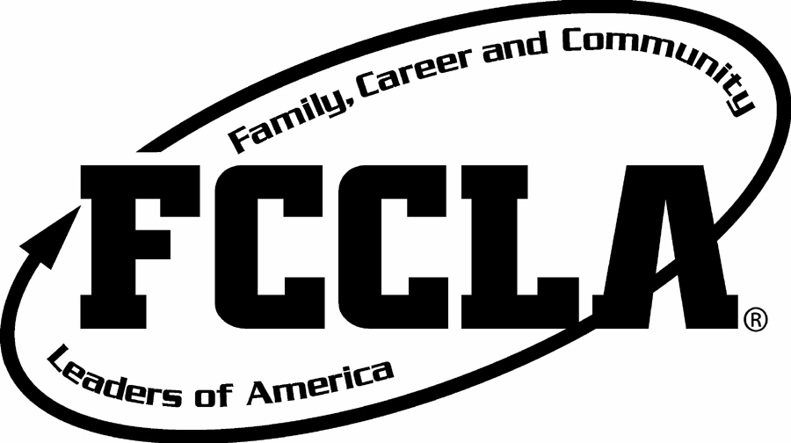

Master Adviser Overview

This program recognizes advisers who have been successful in--
advising an affiliated chapter for a minimum of three years;
promoting the organization;
operating a co-curricular chapter with a balanced program of work;
facilitating youth-centered activities;
keeping abreast of new happenings within the organization.

Criteria for Evaluation
A. Chapter facilitation skills and accomplishments 50%
B. Promoting the organization 30%
C. Professional development 10%
D. Recommendations 10%

Requirements
Candidates must successfully complete three years of advising to be eligible for recognition. Applicants in their third year of advising may apply.

Application Process
The candidate should submit a typed application and the three required recommendations to the state adviser by February 1. This application may be submitted by the candidate or as a nomination by another adviser, teacher educator, local family and consumer sciences supervisor, state adviser, professional colleague or FCCLA member. When nominating candidates, it is best to contact the nominee to obtain complete information.

Review Process
A committee appointed by the state adviser will evaluate each application. The review team may include a variety of individuals such as state officers, teacher educators, local family and consumer sciences supervisor, professional organization representatives or administrators. Applications and state summaries will be forwarded to national headquarters by April 1.

Recognition
All recipients selected at the state level will be recognized at the National Leadership Meeting. Recognition pins will be presented to recipients attending the meeting. Advisers unable to attend will receive their pins by mail following the meeting. Recognition items may be purchased from API, 4471 Nicole Dr., Lanham, Maryland, 20706, 800/507-7007, or www.fccla-store.com.
FCCLA Adviser Recognition Program

2020-21 Master Adviser Application

Instructions

Type all information. Do not attach additional pages or materials except where noted. If you have too much information for the allotted space, select your best examples.

Return the following to your state adviser by February 1:
1. A completed copy of this Master Adviser Application.
2. One recommendation from each of the groups listed below is required. Photocopy the recommendation form provided, giving one copy to each individual.
FCCLA member
school administrator (principal, superintendent or career tech director)
person of candidate’s choice (teacher educator, city supervisor, another teacher, etc.)

CANDIDATE INFORMATION

Name of Candidate

Chapter

School

Principal’s name

School address

City/State/Zip

Home address

City/State/Zip

Phone: School ( ) Fax ( ) Home ( )

Number of years teaching _________ Number of years advising __________

Courses taught: -Comprehensive -Occupational Number of Members in Chapter

Grade levels taught

Family and consumer sciences courses currently teaching

When FCCLA chapter meets (in class or outside of class)

Master Adviser Application continued--Page 2

A. Chapter Facilitation Skills and Accomplishments (50%)

1. Describe how you introduce Family, Career and Community Leaders of America to your students.

2. Describe how projects are planned in your chapter.

3. List types of recognition offered to your chapter members.

Types of Recognition Who Plans This Recognition When Received

4. Briefly describe co-curricular chapter projects completed during the past three years representative of your chapter’s representative of your chapter’s program of work.

5. Size of family and consumer sciences program and FCCLA members during the past three years.

Year Family and Consumer Sciences Enrollment FCCLA Members

B. Promoting the Organization (30%)

1. Candidates for office. Note below the number of officer candidates you have sponsored for positions beyond the chapter level during your teaching career.

__________ District* __________ State __________ National

2. State and nationally sponsored meetings. List the calendar years you have attended any state or nationally sponsored meetings.

District
State
National

* District refers to district, region, parish or any other sub-state level.
Master Adviser Application continued--Page 3

3. Identify state and national publicity resources you have used in the last three years to promote the organization. (video, posters, Teen Times, etc.)

4. Identify ways your chapter publicizes FCCLA in the community and school.

C. Professional Development (10%)

Describe FCCLA leadership roles you have fulfilled beyond your local chapter, in-service
training sessions and other professional development activities during your years as an adviser.

D. Master Adviser Recommendation (10%)

Please photocopy the attached Master Adviser Recommendation Form and secure one recommendation from each of the groups listed below. A total of three recommendations is require

FCCLA member
School administrator (principal, superintendent or vocational director)
Person of candidates choice (teacher educator, city supervisor, another teacher, etc.)
FCCLA Adviser Recognition Program

Master Adviser Recommendation

Applicant Instructions

Type your name in the blank below and send this form to three people who can evaluate your performance as an FCCLA Adviser. (See instructions on Master Adviser Application).

Evaluator Instructions

_____________________________________________ is applying for recognition as a Master Adviser.
Your assistance in evaluating this applicant will be appreciated.

Please read the information below and use the attached form to rate the candidate in these areas. Return this form to the candidate no later than January 15. Thank you for your recommendation.

A Master Adviser is one who has--

completed or is completing three years of advising;

■ communicated the opportunities of Family, Career and Community Leaders of America
(local, state and national levels) to students in the family and consumer sciences program;

■ publicized Family, Career and Community Leaders of America activities that promote a
positive, up-to-date image of family and consumer sciences;

advised a chapter that carries out a program of work that--

--relates to the purposes of the organization;

--includes curriculum-related projects, balanced by fund raising activities, membership promotion, social events, public relations events and business meetings;

--includes local activities related to state and national projects (such as membership promotions, Families First, STAR Events, Power of One, Financial Fitness or Leaders at Work);

--includes opportunities for individualized, competitive and cooperative actions;

helped members plan projects related to their own concerns;

encouraged chapter activities relating to the scope of family and consumer sciences subjects being taught.
FCCLA Master Adviser Recommendation

Name of candidate _____________________________________________

Instructions

Use this form to rate the candidate’s advising skills, checking the appropriate rating. Return this form to the candidate no later than January 15.

Yes No Don’t Know

1. Promotes FCCLA involvement to students.
2. Develops a relevant program of work--
relates to family and consumer sciences education;
develops a balanced program of work;
involves students in state and national activities;
includes cooperative, competitive and individualized
activities.
3. Encourages youth-planned chapter projects.
4. Includes chapter projects representing the scope of family
and consumer sciences subjects being taught.
5. Publicizes Family, Career and Community Leaders of America.

Comments:

___________________________________________
Signature Date

Person completing this form: Indicate your position:

Name FCCLA Member
Title School Administrator
School (principal, superintendent or
Address career tech director)
City/State/Zip Person of candidates choice
Phone ( ) (teacher educator, city supervisor, another teacher, etc)
FCCLA Adviser Recognition Program

Adviser Mentor Overview

This program recognizes the skills of experienced advisers who help orient and train new advisers. It also recognizes advisers who have been successful in--
achieving Master Adviser recognition;
devoting two years to new adviser assistance;
assuming adult leadership roles in Family, Career and Community Leaders of America;
conducting adviser workshops;
attending training workshops;
using national and state FCCLA resources.

Criteria for Evaluation
A. New adviser assistance 45%
B. Leadership roles 35%
C. Professional development 10%
D. Recommendations 10%

Requirements
The candidate must have--
attained Master Adviser recognition;
assisted beginning advisers for a minimum of two years after receiving Master Adviser
recognition.

Application Process
A typed application and at least three recommendations should be submitted to the state adviser by February 1. This application may be submitted by the candidate or as a nomination by another adviser, teacher educator, local family and consumer sciences supervisor, state adviser, professional colleague or FCCLA member. Nominees may need to be contacted to obtain complete information.

Review Process
A committee appointed by the state adviser will evaluate each application. The review team may include a variety of individuals such as state officers, local advisers, teacher educators, local family and consumer sciences supervisors, professional organization representatives or administrators. Applications and state summaries will be forwarded to national headquarters by April 1.

Recognition
All recipients selected at the state level will be recognized at the National Leadership Meeting. Recognition pins will be presented to recipients attending the meeting. Advisers unable to attend will receive their pins by mail following the meeting. Recognition items may be purchased from API, 4471 Nicole Dr., Lanham, Maryland, 20706, 800/507-7007, or www.fccla-store.com.
FCCLA Adviser Recognition Program

2020-21 Adviser Mentor Application

Instructions

Type all information. Do not attach additional pages or materials except where noted. Responses to questions should be based on your work as an Adviser Mentor during a two-year period.

Return the following to your state adviser by February 1:
1. A completed copy of this Adviser Mentor Application.
2. One recommendation from each of the groups listed below is required. Photocopy the recommendation form provided, giving one copy to each individual.
FCCLA member
school administrator (principal, superintendent or career tech director)
person of candidate’s choice (teacher educator, city supervisor, another teacher, etc.)

CANDIDATE INFORMATION

Name of Candidate

Chapter

School

Principal’s name

School address

City/State/Zip

Home address

City/State/Zip

Phone: School ( ) Fax ( ) Home ( )

Number of years teaching _________ Number of years advising __________

Courses taught: -Comprehensive -Occupational Number of Members in Chapter

Grade levels taught

Family and consumer sciences courses currently teaching

When FCCLA chapter meets (in class or outside of class)

Adviser Mentor Application continued--Page 2

A. New Adviser Assistance (45%)

List names of advisers you have helped develop a chapter (new or reaffiliated) since you achieved Master Adviser status. Describe both how you helped them become involved in state and national programs and develop advising skills.

Year Adviser’s Name Chapter How You Helped Them

B. Leadership Roles (35%)

Describe FCCLA leadership roles you have fulfilled and adviser training workshops you have conducted at the district, state and national levels.

List your most rewarding accomplishments as an Adviser Mentor.

Adviser Mentor Application continued--Page 3

C. Professional Development (10%)

Describe FCCLA leadership roles you have fulfilled beyond your local chapter during your years as an adviser.

D. Adviser Mentor Recommendations (10%)

Please photocopy the attached Adviser Mentor Recommendation Form and secure one recommendation from each of the groups listed below. A total of 3 recommendations are required.

FCCLA member
School administrator (principal, superintendent or career tech director)
Person of candidates choice (teacher educator, city supervisor, another teacher, etc.)

FCCLA Adviser Recognition Program

Adviser Mentor Recommendation

Applicant Instructions

Type your name in the blank below and send this form to three people who can evaluate your performance as an FCCLA Adviser.

Evaluator Instructions

_____________________________________________ is applying for recognition as a Adviser Mentor.
Your assistance in evaluating this applicant will be appreciated.

Please read the information below and use the attached form to rate the candidate in these areas. Return this form to the candidate no later than January 15. Thank you for your recommendation.

An Adviser Mentor is one who has--

devoted at least two years to assisting beginning or returning advisers;

encouraged teachers to establish chapters;

encouraged beginning advisers to participate in state and national activities;

helped beginning advisers develop plans and systems of management;

provided positive reinforcement to new advisers;

listened to beginning advisers’ concerns;

conducted adviser training activities;

assumed adult leadership roles in Family, Career and Community Leaders of America;

attended recent FCCLA meetings beyond the local level;

used current FCCLA resources.
FCCLA Adviser Mentor Recommendation

Name of candidate _____________________________________________

Instructions

Use this form to rate the candidate’s advising skills, checking the appropriate rating. Return this form to the candidate no later than January 15.

Yes No Don’t Know

1. Assists beginning advisers to--
establish new chapter;
participate in state and national activities;
develop plans and systems of management.

2. Listens to beginning advisers’ concerns and
provides positive reinforcement.
3. Assumes adult leadership roles in FCCLA.
4. Conducts adviser training activities.
5. Participates in professional development for advisers.
6. Attends FCCLA meetings beyond local level.
7. Uses FCCLA resources.

Comments:

___________________________________________
Signature Date

Person completing this form: Indicate your position:

Name FCCLA Member
Title School Administrator
School (principal, superintendent or
Address career tech director)
City/State/Zip Person of candidates choice
Phone ( ) (Teacher educator, city supervisor, another teacher,
etc.)

