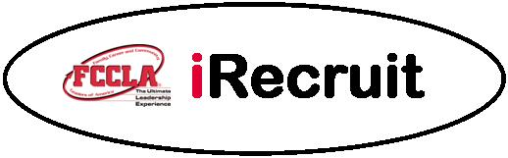

Alabama Membership Increase Project

To encourage an increase in membership, the 2020-21 State FCCLA Executive Council has elected to continue the Alabama iRecruit Membership Increase State Project. A local chapter will receive the distinguished recognition of having the largest percentage increase of members by increasing their membership for the current academic year, August 1 – July 31. This application, along with required documentation, must be mailed to the state adviser by January 15 for a chapter to receive this honor. Applications from chapters meeting the criteria for this award will be reviewed. The winning chapter will receive a special chapter award and be recognized at the state leadership conference. Note: This state project does not lead to a national project award.

APPLICATIONS MUST BE POSTMARKED BY JANUARY 15
PLEASE TYPE YOUR INFORMATION

Name of Chapter
School Name
School Address
City/Zip
School Phone |  | ( )
Adviser’s Name
If more than one adviser, list all names
Principal’s Name
Previous Year’s Chapter Membership
Present Year’s Chapter Membership
Percentage Increase of Chapter Membership
Please attach your chapter affiliation forms for this academic year and the previous academic year. (These forms can be downloaded and printed from the national affiliation Web site, registermychapter.com. Affiliated means the dues and membership affiliation form for an FCCLA chapter have been received at national headquarters.)
I certify the above information in this application is correct.

Chapter President |  |  |  |  |  | Date
(Signature)*
Chapter Adviser |  |  |  |  |  | Date
(Signature)*
Email Application by February 15 to:
Theresa Long, ALAFCCLA State Adviser |  |  |  |  | Email: theresa.long@alsde.edu
State Approved |  |  |  |  |  | Date
*May type in signature to use via e-mail or print and sign for mailing or fax.

