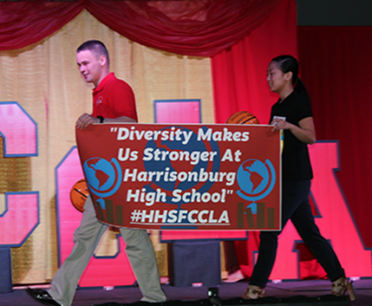
ALABAMA FCCLA BANNER PARADE 2022
- The Banner Parade is designed to encourage FCCLA chapters to display their work and promote their program in a collaborative, creative way.
- Each FCCLA Chapter is encouraged to design a FCCLA Banner.
- The Banner Parade will be conducted at the FCCLA State Leadership Conference.
- The winning design will be recognized at State Leadership Conference.

BANNER PARADE GUIDELINES:

- The banner can be NO larger than 2 ½ feet by 4 ½ feet. (may be vertical or horizontal)

- The banner design must reflect the theme for State FCCLA for the current year. (Lights, Camera, Leadership)

- The banner must include the full name of the chapter’s school.

- The banner should be personalized to reflect the chapter’s achievements/activities for the current year.

- Lettering should be large enough to be read from a distance.

- Commercially made designs are not allowed in the competition.

- Banners should be designed so they can be easily carried in the Banner Parade.

- Banners must be constructed so that all parts (letters, pictures, etc) remain intact during the parade.

- Battery powered accessories are allowed as part of the banner.

- “Bake It to Make It Covid Safe” donations will be dropped off during banner parade.

JUDGING RUBRIC:
Followed Guideline Instructions | 0 5 10 points
Reflects State Theme | 0-10 points
Reflects Chapter’s Activities | 0-10 points
Visual Appeal | 0-10 points

CLASSROOM INTEGRATION IDEAS (Optional):

- Display your completed banner at your school to promote your program.
- Use this as a classroom project.
- Enter your FCCLA chapter in the Homecoming Parade and lead with your banner.
- Take a picture of the banner with the FCCLA members and submit it in the local paper along with an article detailing your chapter’s accomplishments.

