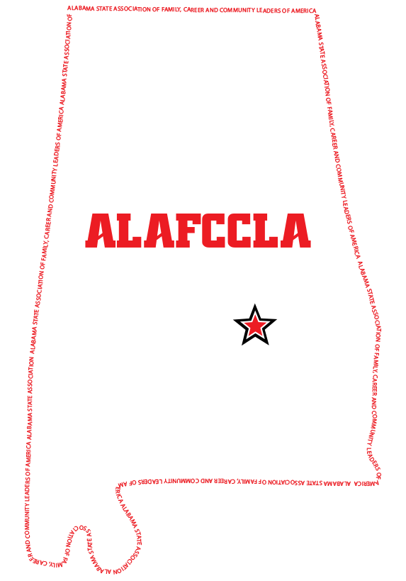
ALABAMA ASSOCIATION OF FAMILY, CAREER AND COMMUNITY LEADERS OF AMERICA (FCCLA) FOUNDATION SCHOLARSHIP

All secondary Alabama students who meet the eligibility criteria may apply for a $1,000 Alabama Association of Family, Career and Community Leaders of America Foundation Scholarship to be awarded at the annual ALAFCCLA State Leadership Conference.

Criteria for Eligibility

1. Applicant must have taken or be enrolled in a Family and Consumer Sciences class and have been a member of an affiliated chapter of the Alabama Association of Family, Career and Community Leaders of America.

2. Applicant will graduate from high school during the school year application is submitted.

3. Applicant will enroll and major in a field of Family and Consumer Sciences or Family and Consumer Sciences Education at a post-secondary or four-year institution in Alabama offering such degrees to receive the scholarship.

Terms of Agreement

1. A check for one payment of $1000 will be paid to the recipient upon proof of enrollment in a postsecondary or four-year college or university offering degree programs in a field of Family and Consumer Sciences or Family and Consumer Sciences Education.

2. This scholarship is non-renewable.

3. The scholarship application will be judged by a committee composed of:

(a) Family and Consumer Sciences educator
(b) Family and Consumer Sciences specialist
(c) Administrator

(No person may serve on a selection committee who has vested interest in an applicant.)

INSTRUCTIONS FOR COMPLETING THE APPLICATION

Complete the application and attach the following:

An official copy of school transcript
Verification of ACT score
Three letters of recommendation:
- Family and Consumer Sciences teacher
- Guidance Counselor or School official
- Community Leader
Digital wallet size photograph
Copy of “FCCLA Chapter Affiliation Form” and Member Roster

Email a typed application, in pdf format, no later than February 15, 2023 to:

Theresa Long, ALAFCCLA State Adviser
theresa.long@alsde.edu
Call (334) 694-4991 if you have questions regarding this application.
ALABAMA ASSOCIATION OF FAMILY, CAREER AND COMMUNITY LEADERS OF AMERICA (FCCLA) FOUNDATION SCHOLARSHIP

CRITERIA FOR SELECTION

Name

Description of local, district, state, and national involvement in Family, Career and Community Leaders of America programs and projects | 25 pts. | Score  _____
Description of leadership involvement in  school and community activities | 15 pts. | _____
Description of why a Family and Consumer Sciences career has been chosen | 15 pts. | _____
Description of reason for applying for this scholarship | 15 pts. | _____
Content of letters of recommendation:  Three letters of recommendation from  - Family and Consumer Sciences teacher  - Guidance counselor or School official  - Community Leader | 15 pts. | _____
Application process followed:  - Attached official copy of transcript & verification of ACT score  - Attached wallet size photograph  - Attached “FCCLA Chapter Affiliation Form” and member roster | 15 pts. | _____
TOTAL SCORE | 100 pts. | _____
Signature of Judge | Date

OFFICIAL APPLICATION
ALABAMA ASSOCIATION OF FAMILY, CAREER AND COMMUNITY LEADERS
OF AMERICA (FCCLA) FOUNDATION SCHOLARSHIP
Page 1

Personal Information
Applicant’s Name
Home Address
City/State/Zip
Cell Phone |  |  |  | Date of Birth
Parent/Guardian (Mother) |  |  |  | Occupation |  |  | Business Phone
Parent/Guardian (Father) |  |  |  | Occupation |  |  | Business Phone
Chapter adviser: |  |  |  |  | E-mail
School: |  |  |  |  | Phone
Address:
City/State/Zip:

Educational Background
List all high schools and post-secondary schools attended.
Attach a copy of your transcripts to this application form. (REQUIRED)

School Name & Address | Years | Course of Study (Major) | Graduation Date

List the accredited postsecondary institution name, address, business office phone where you plan to attend or are currently attending, the academic year you will be attending.
- Have you made application to the institution? | Yes |  | No
- Have you been accepted by the institution? | Yes |  | No

Institution Information | Academic Year | College Major
ALAFCCLA FOUNDATION SCHOLARSHIP APPLICATION
Page 2
Community Involvement/Work Experience

1. Describe local, district, state, and national involvement in Family, Career and Community Leaders of America programs and projects.

2. List activities relevant to community involvement and/or work experience providing specific examples.

ALAFCCLA FOUNDATION SCHOLARSHIP APPLICATION
Page 3
Related Information

3. Describe why you selected a career in Family and Consumer Sciences.
4. Explain why you are applying for this scholarship.
5. List courses you have taken in Family and Consumer Sciences while in Grades 7-12.
If selected, we agree to the Terms of Agreement for the Alabama Association of Family and Consumer Sciences Scholarship.

Applicant Signature |  | Date
Parent Guardian Signature |  | Date

